** Knowledge Organiser – Light (Science Year 5 and 6)**

You should have found out that light can only travel in a straight line. The light was mostly blocked by the card but some of the light travelled through the holes and you could see it come out the other end.

Light travels in straight lines.

|  |  |
| --- | --- |
| **Key Vocabulary** | **Definition** |
| Absorb | To take in. |
| Light rays | Imaginary lines used to explain how waves of visible light move. |
| Reflect | To cast back light from a surface. |
| Straight | To move in one direction only. |

[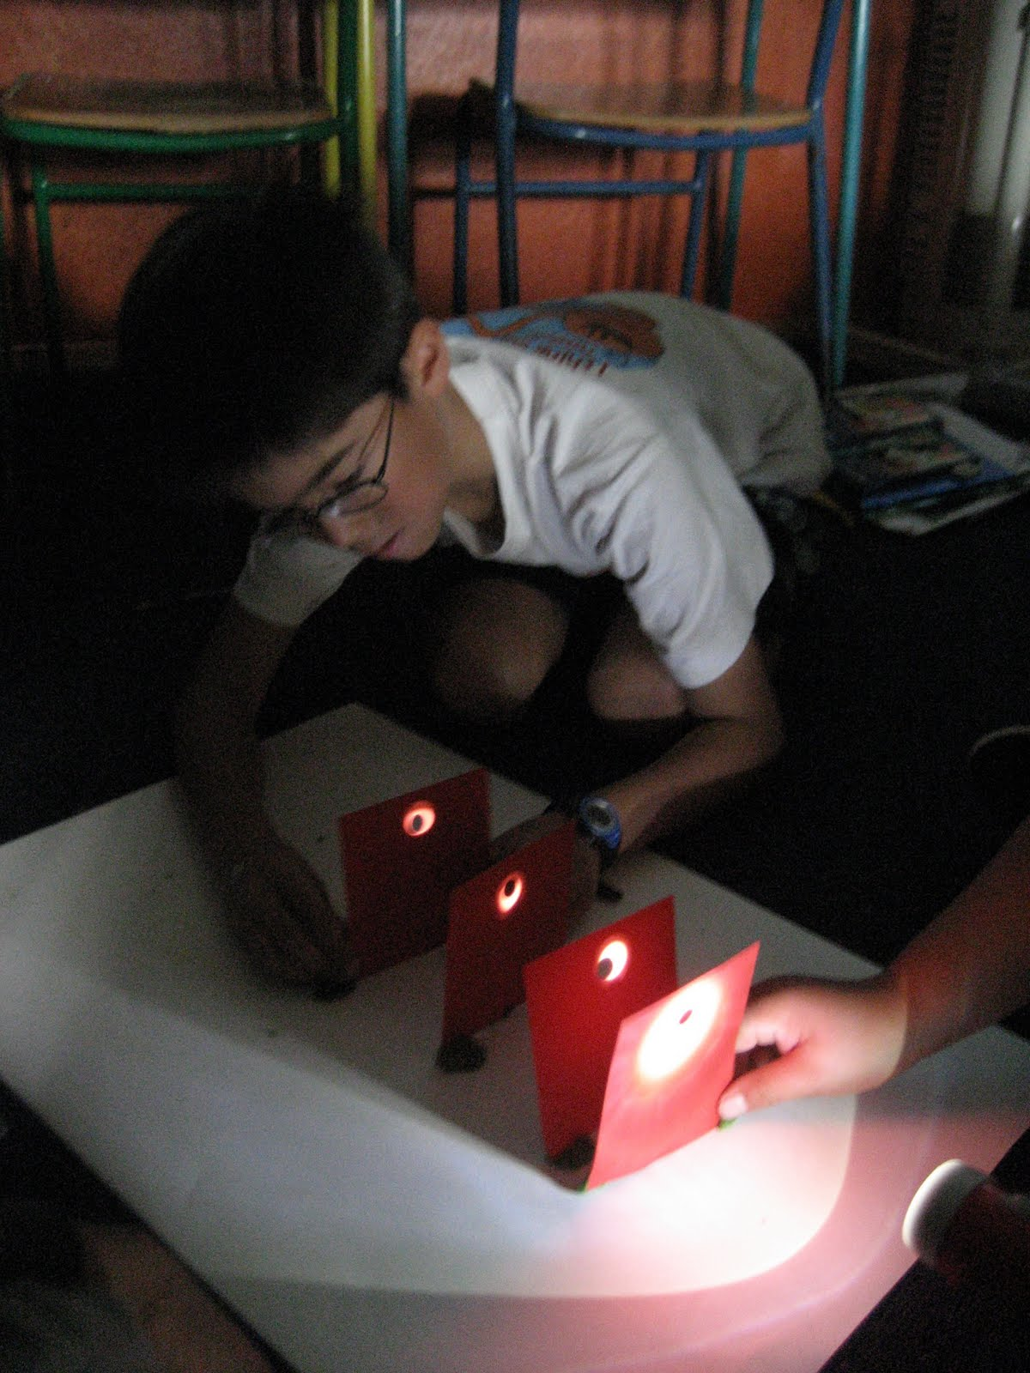](http://www.google.co.uk/url?sa=i&rct=j&q=&esrc=s&source=images&cd=&cad=rja&uact=8&ved=0ahUKEwiX16qg9ZnRAhWKfRoKHRpqDRQQjRwIBw&url=http://scienceehs.blogspot.com/2011/02/does-light-travel-in-straight-line.html&bvm=bv.142059868,d.ZWM&psig=AFQjCNFOupjSnDrB8rL4KbL1gPTcuXDSdw&ust=1483117652792704)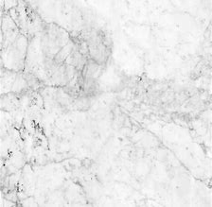

Larger crystals that interlock.

Marble

Light reflects off a mirror like a ball hitting a hard surface. The angle it hits the mirror at is the same that it is reflected at.

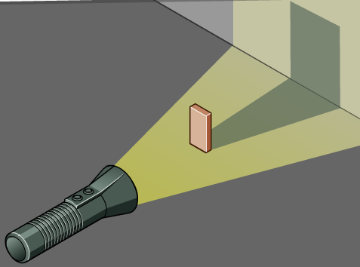

This is because light travels in straight lines and cannot bend around an opaque object in their path. A concentrated light source casts a sharp shadow.

Light travels in straight lines. Some objects will form a shadow when light hits them. This is because they block the light. Shadows are the same shape as the object that casts them.

[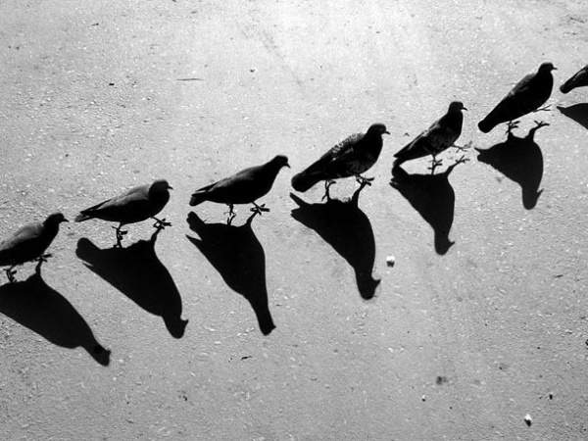](https://www.google.co.uk/url?sa=i&rct=j&q=&esrc=s&source=images&cd=&cad=rja&uact=8&ved=0ahUKEwjOy7uX-pnRAhWBvBQKHbO_AbgQjRwIBw&url=https://uk.pinterest.com/tenebraechoir/shadows/&bvm=bv.142059868,d.ZWM&psig=AFQjCNGI-6pqYsxtpbrZsw6MbLccrMo2DA&ust=1483119860012327)

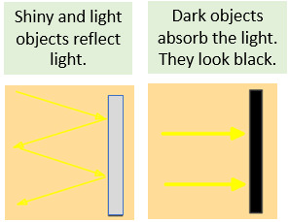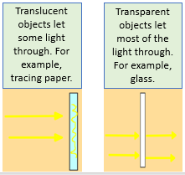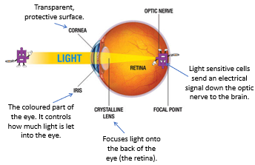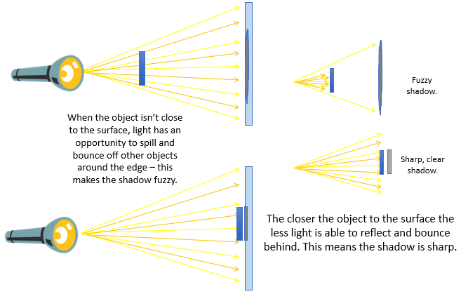

The image appears upside down because light rays cross each other in the eye. The brain interprets the image so that we see it the right way up.