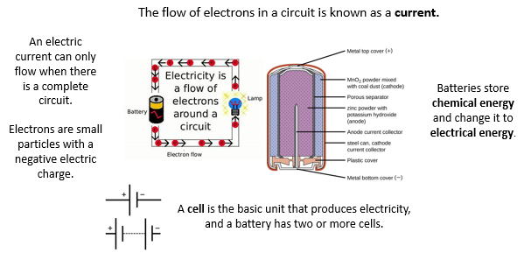** Knowledge Organiser – Electricity (Science Year 5 and 6)**

|  |  |
| --- | --- |
| **Key Vocabulary** | **Definition** |
| Terminal | Point of connection for closing an electric circuit. |
| Voltage | Force of an electrical current. |
| Current | Flow of electrical charge. |
| Resistance | Reducing the electric current flow through a material. |

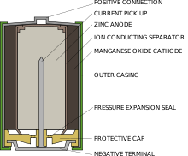

Larger crystals that interlock.

Marble

Voltage is the electrical force which causes electrons to flow around a circuit. It is measured in units called volts (V).

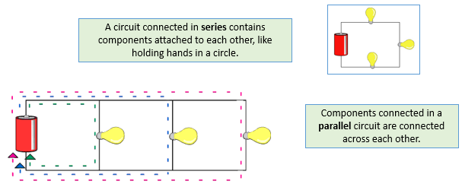

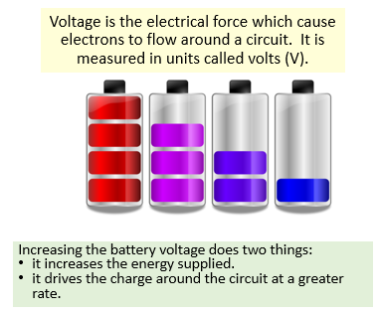

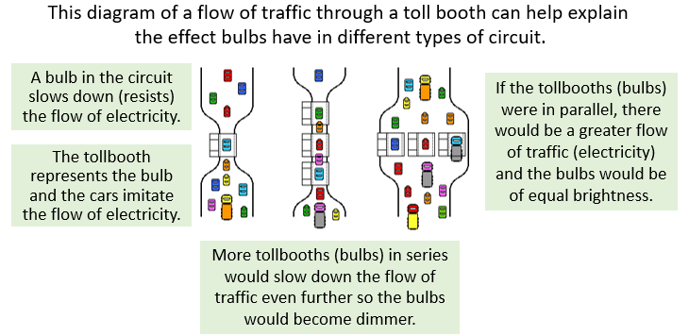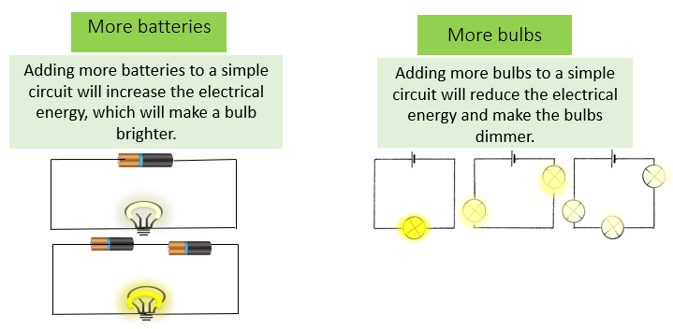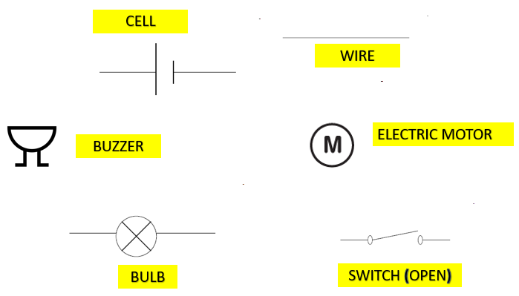

This diagram of a flow of traffic through a tollbooth can help explain the effect bulbs have in different types of circuit.