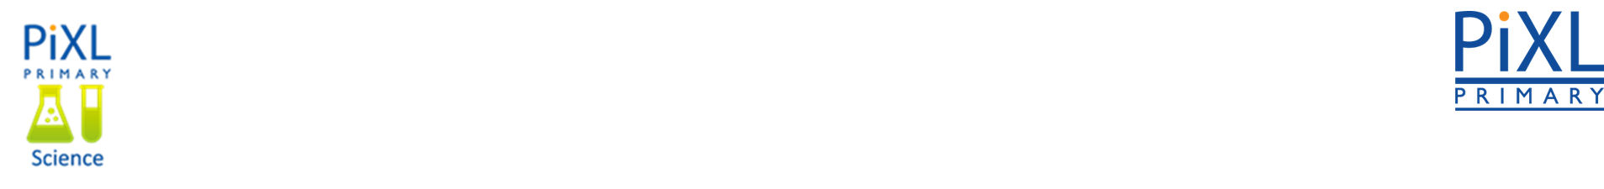 **Knowledge Organiser – Animals including Humans (Science Year 5 and 6)**

|  |  |
| --- | --- |
| **Key Vocabulary** | **Definition** |
| Egg | An oval object laid by a female bird, reptile, fish or invertebrate that grows into a young offspring. |
| Live young | Are born to mammals. |
| Development | A new stage in a changing situation. |
| Adolescent | Developing from a child into an adult. |
| Puberty | When adolescents become able to reproduce. |
| Gestation | Process in which babies grow inside their mother's body before they are born. |

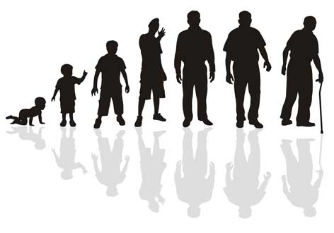

**Baby**

**Toddler**

**Child**

**Adolescent**

**Adult**

**Old Age**

**Stages of the Human Life Cycle**

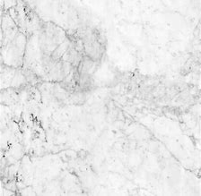

Larger crystals that interlock.

Marble

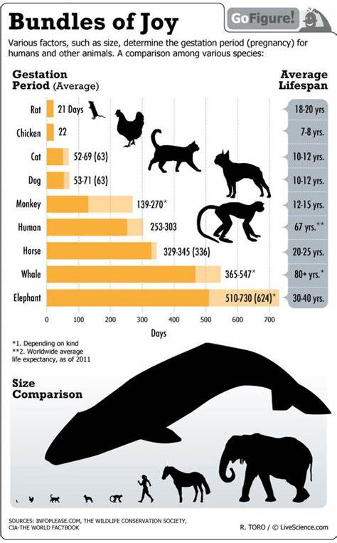

This continues in waves until the vibrations run out of energy. If the vibrations reach your ears, you will hear the sound.

* This is the period of time the fetus spends in the womb.
* The time starts from conception and ends at birth.
* For humans, the gestation period is around nine months.

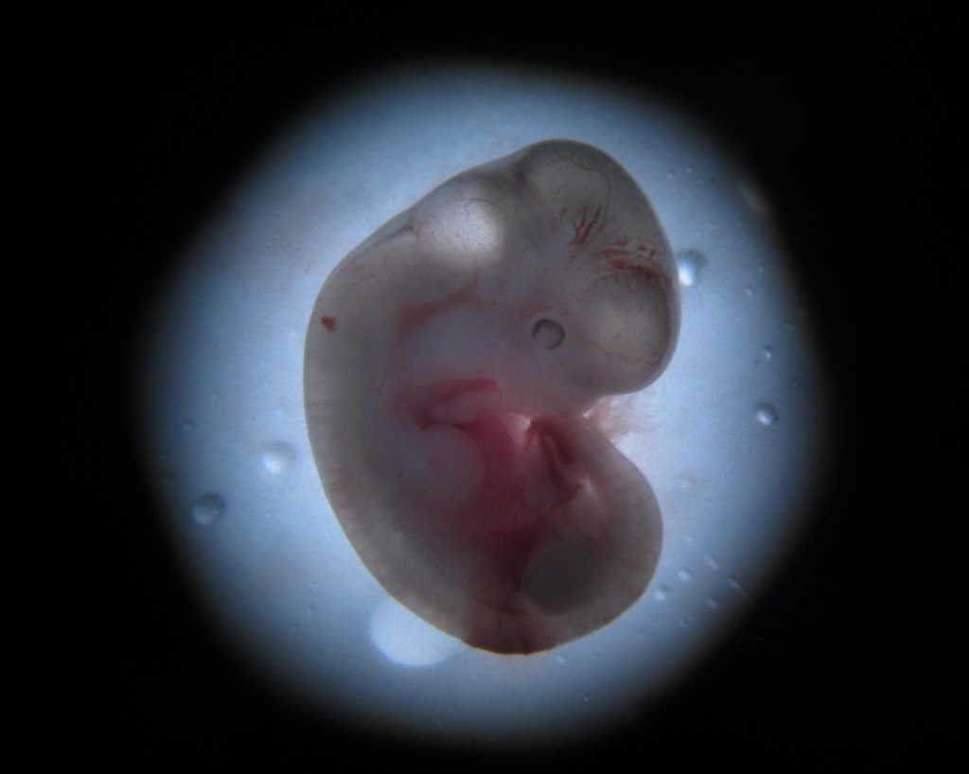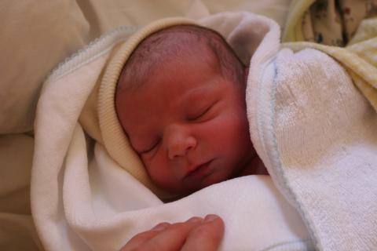

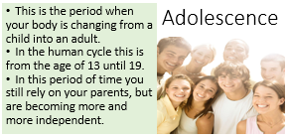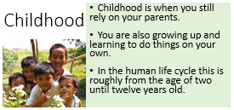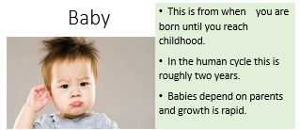

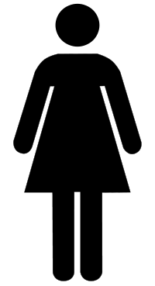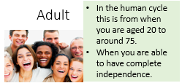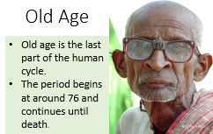

**testicles mature and grow**

**hair on face grows**

**voice gets deeper**

**breasts start to grow**

**periods start**

**hips grow wider**

**pubic hair grows**

**body grows**

Changes in Puberty