** Knowledge Organiser – Animals including Humans (Science Year 5 and 6)**

This is a basic diagram of the circulatory system. It shows the flow of blood around your body.

|  |  |
| --- | --- |
| **Key Vocabulary** | **Definition** |
| Circulatory system | System that moves blood throughout the body. |
| Blood | Body fluid that carries oxygen and other substances around the body. |
| Blood vessels | Tubes that carry blood through the body. |
| Oxygen | Used to make energy and is absorbed into the body through the lungs. |
| Carbon dioxide | Waste product made when the body makes energy. It leaves the body through the lungs. |
| Lungs | Organs in the body used to breathe air in and out. |



Larger crystals that interlock.

Marble

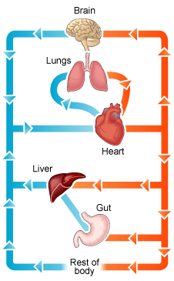

The human heart works like a pump as it sends blood around your body to keep you alive. It pumps the blood continuously through the circulatory system.

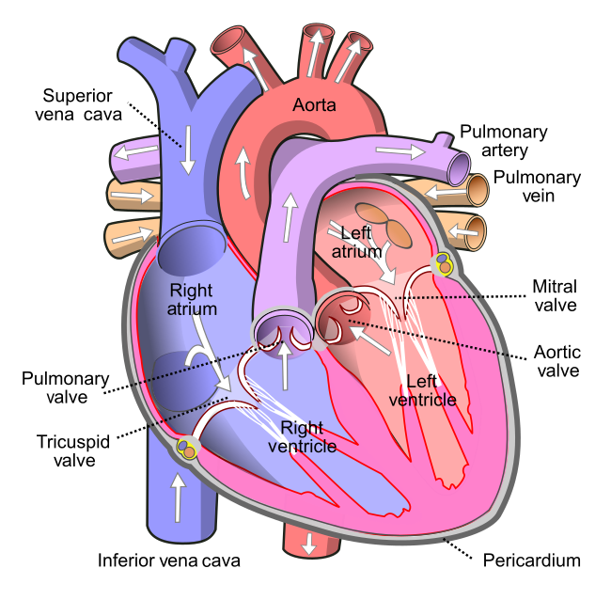

This energy is used all over the body for movement, growth, repair and defence.

Food + Water + O2

Energy + CO2

Red blood cells transport oxygen. White blood cells fight disease. Platelets cause the blood to clot when you have a cut.

The lungs are the organs that we use to breathe.

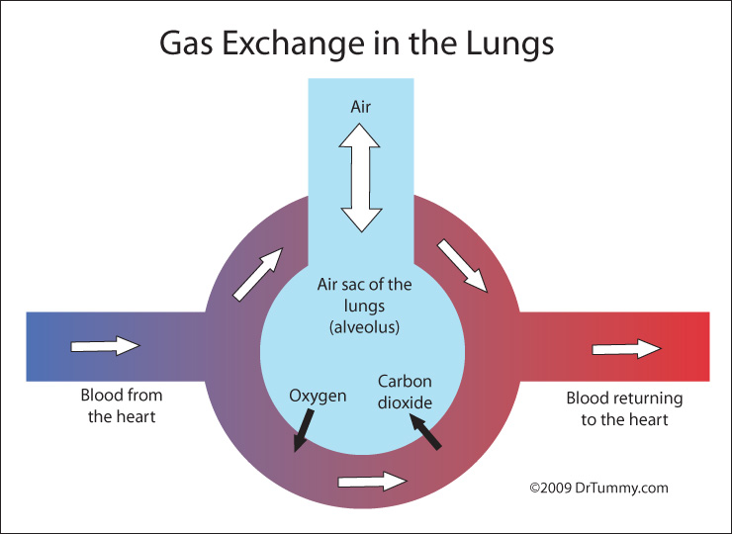

[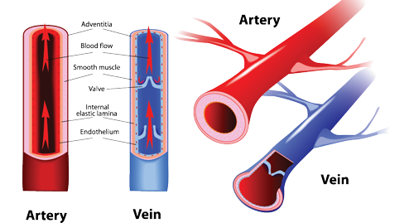](http://www.google.co.uk/url?sa=i&rct=j&q=&esrc=s&source=images&cd=&cad=rja&uact=8&ved=0ahUKEwjh2NGeg_fSAhWFcBoKHbtMCp0QjRwIBw&url=http://combiboilersleeds.com/keywords/veins-1.html&bvm=bv.150729734,d.ZGg&psig=AFQjCNELoGuQd7ahLfruvqcFgDA9qmsGjg&ust=1490715754628236)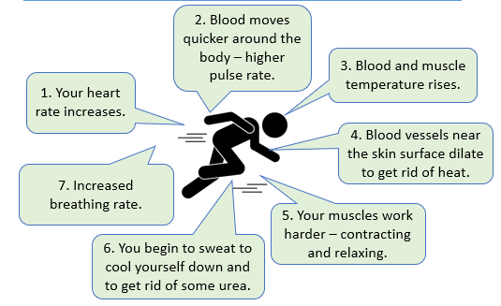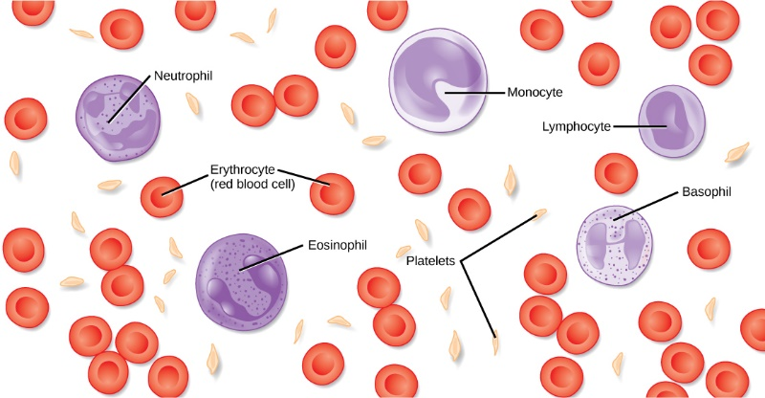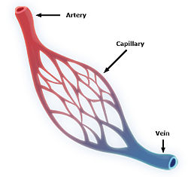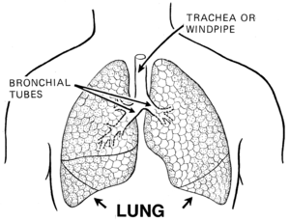

Capillaries are very tiny blood vessels that connect arteries and veins.

Veins carry blood from the body to the heart, whereas arteries carry blood away from the heart to the body.