** Knowledge Organiser – Sounds (Science Year 3 and 4)**

Sound is made when something vibrates.

|  |  |
| --- | --- |
| **Key Vocabulary** | **Definition** |
| Sound | Vibrations that travel through a medium and can be heard when they reach the ear. |
| Vibration | Movement back and forth. |
| Pitch | Frequency of a sound wave. |
| Volume | Three-dimensional space occupied by a gas, liquid or solid. |
| Insulation | Substance that stops heat, electricity or sound from passing. |

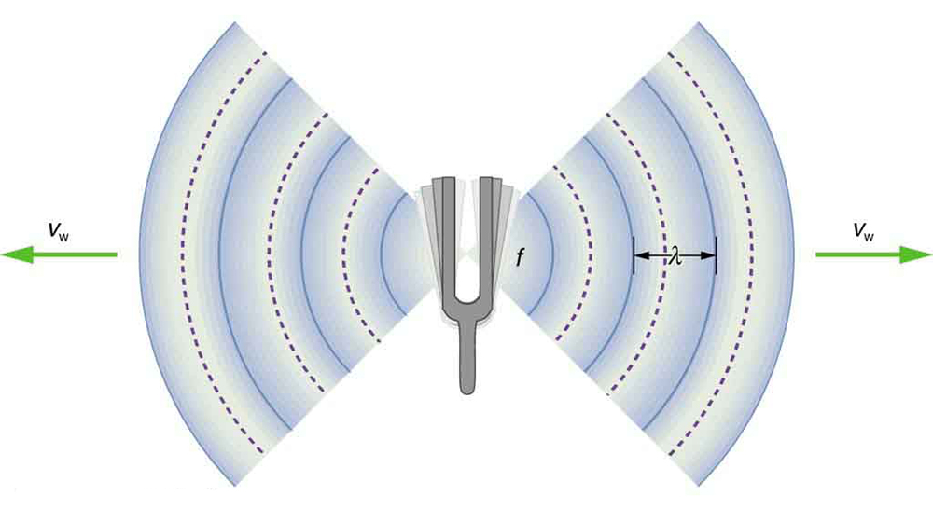

*Vibration* is a rapid back-and-forth movement.



Larger crystals that interlock.

Marble

Sound waves are caused by vibrations in the air.

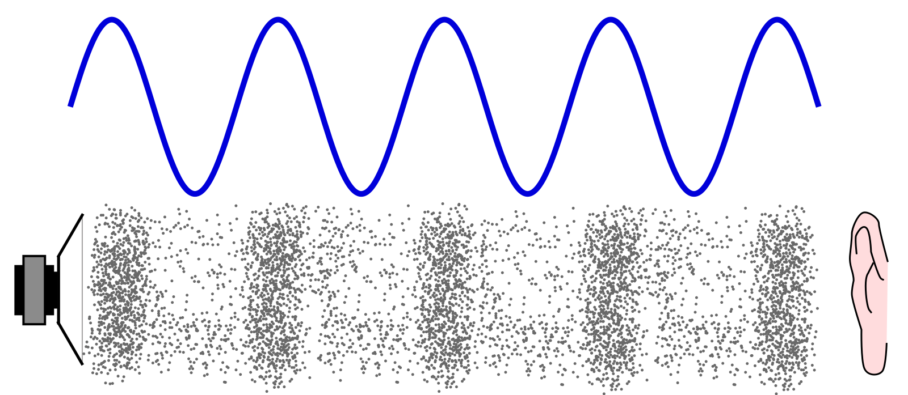

When an object vibrates, it causes movement in the air particles.



This continues in waves until the vibrations run out of energy. If the vibrations reach your ears, you will hear the sound.



These air particles vibrate too and then bump into other air particles which then start to vibrate and so on.

Sound is a form of energy like light. Both travel in waves and can be reflected



This continues in waves until the vibrations run out of energy. If the vibrations reach your ears, you will hear the sound.

A sound vibration spreads out in all directions from its sources, like ripples from a pond.

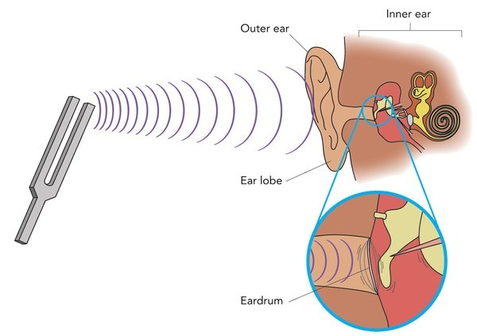

The number of vibrations per second is called the frequency of sound.

Particles of air knock into each other.

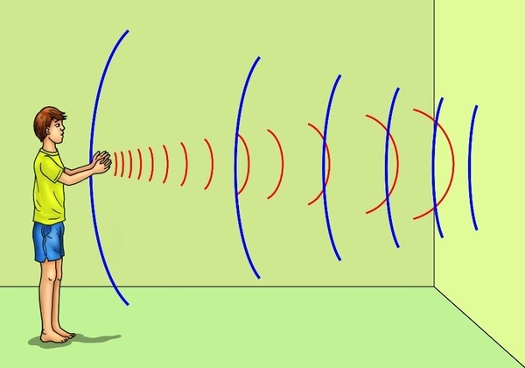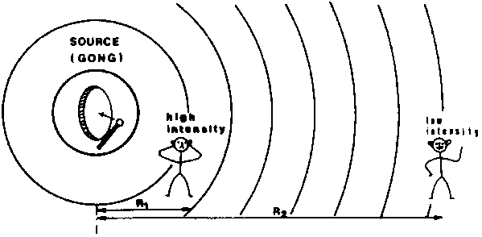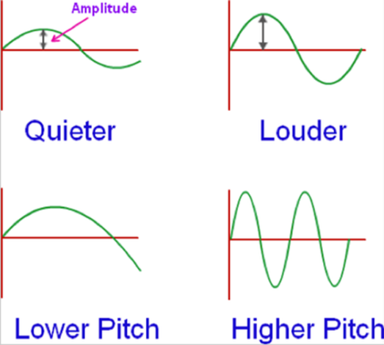

The vibrations are converted to electrical signals that your brain interprets as sound.

These vibrations reach the ear and make the eardrum vibrate.

Sound that has been reflected is called an echo.

Sounds get softer the further away you are from the source of the sound because the vibrations lose strength as they travel through the air.

VOLUME (amplitude) describes how loud or quiet a sound is.

PITCH describes how low or high a sound is.