|  |  |
| --- | --- |
| **Key Vocabulary** | **Definition** |
| Rock | Natural substance, made up of one or more minerals. |
| Fossil | Trace or remains of an ancient living thing. |
| Igneous rock | Formed by the cooling and solidifying of molten materials. |
| Metamorphic rock | Rock that was once one form of rock but has changed to another under the influence of heat and pressure. |
| Sedimentary rock | Formed through the depositing and solidifying of sediment. |
| Peat | Formed when plant material does not fully break down in acidic conditions, with no air. |

** Knowledge Organiser – Rocks (Science Year 3 and 4)**

There are 3 main types of rock:

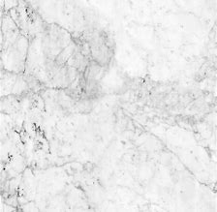

**Igneous**

**rock**

**Sedimentary**

**rock**

**Metamorphic**

**rock**

Pumice

Granite

Obsidian

Sandstone

Limestone

Marble

Slate

Larger crystals that interlock.

Marble

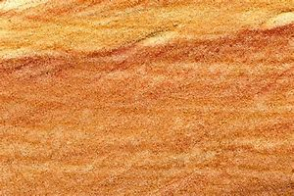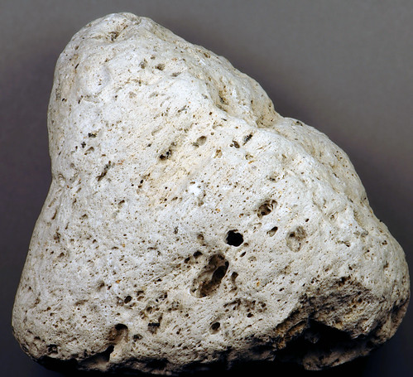

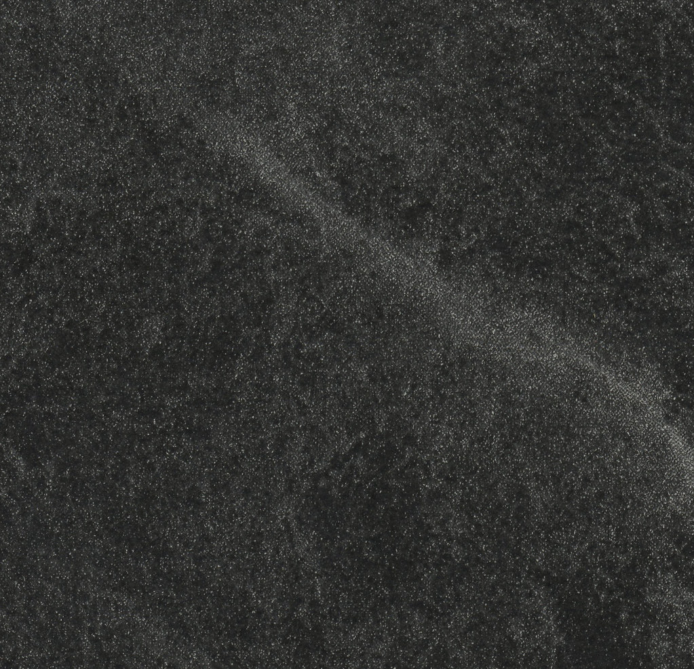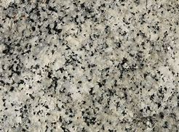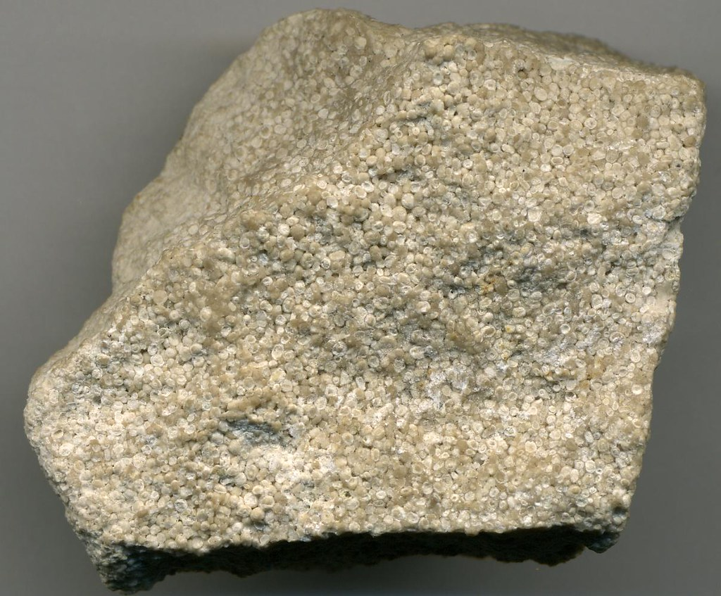

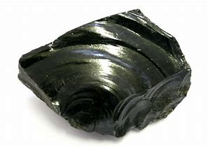

Mantle

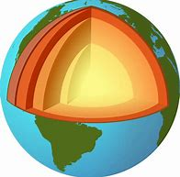

Crust

The Earth

has 3 layers!

Minerals are made of elements.

Elements are simple substances that cannot be broken down into any other substance.

Core

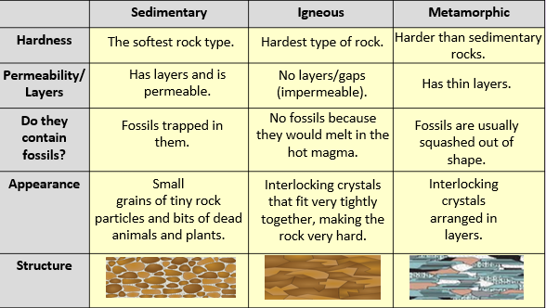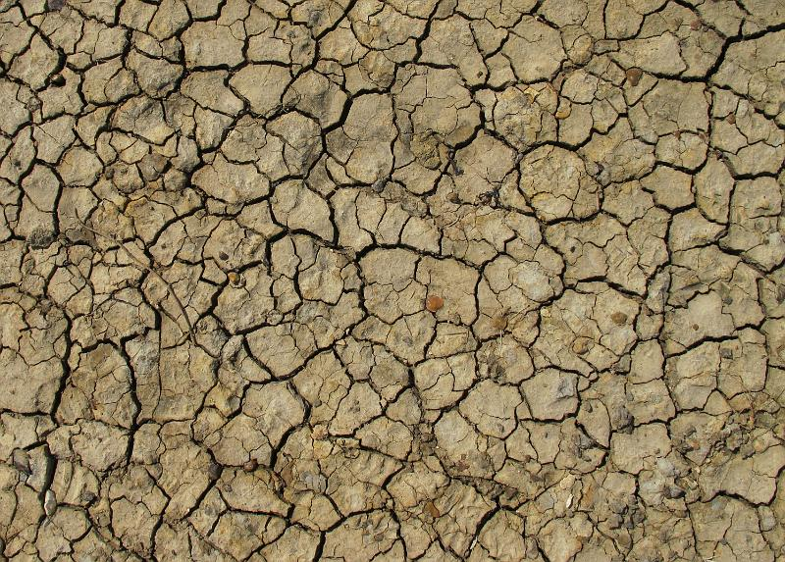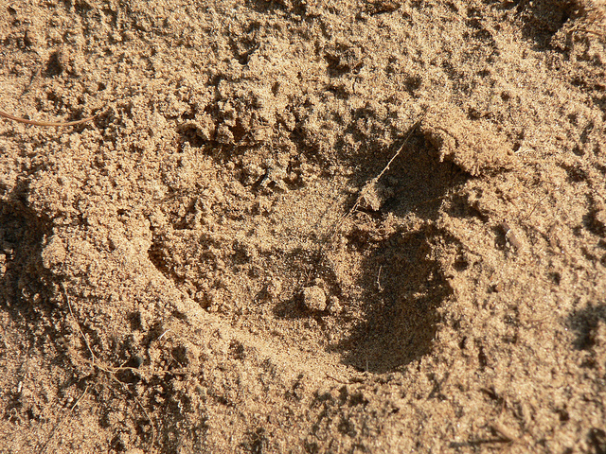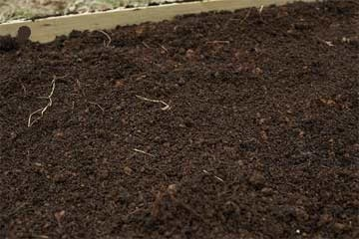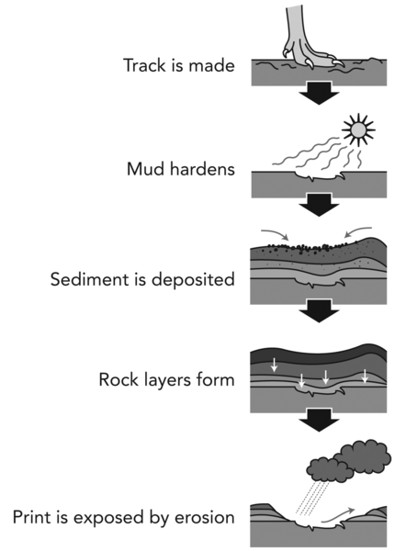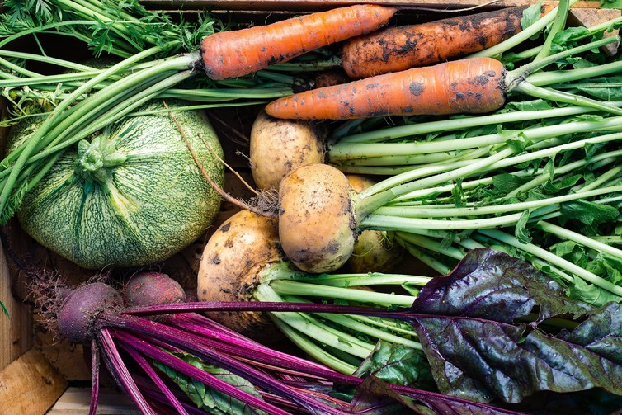

Loam soils are composed of a mixture of clay, sand and silt.

Clay

Silt

Sand

There are three main types of soil:

When a rock doesn’t let water through it, the rock is said to be **impermeable.**

When a rock lets water through, the rock is said to be **permeable.**

Fossil formation

Vitamins and minerals