Key Vocabulary | Definition
Classification | Ways of naming and grouping living things by their similarities and differences.
Vertebrate | An animal with a backbone.
Invertebrate | An animal without a backbone.
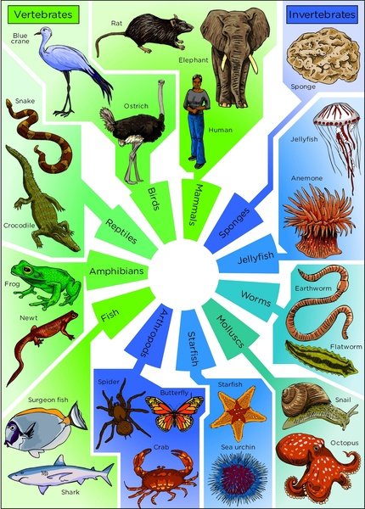

Knowledge Organiser – Living Things (Science Year 3 and 4)


Larger crystals that interlock.
Marble

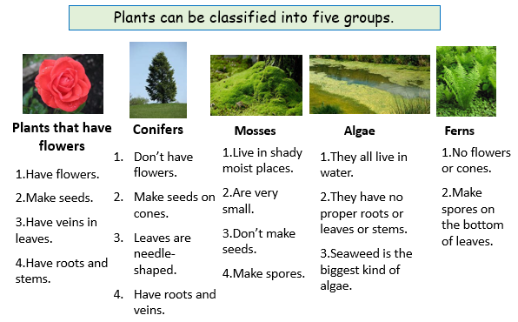

Classification keys allow you to ask a series of questions about a living organism to help you identify it.
Vertebrates are animals with a backbone.
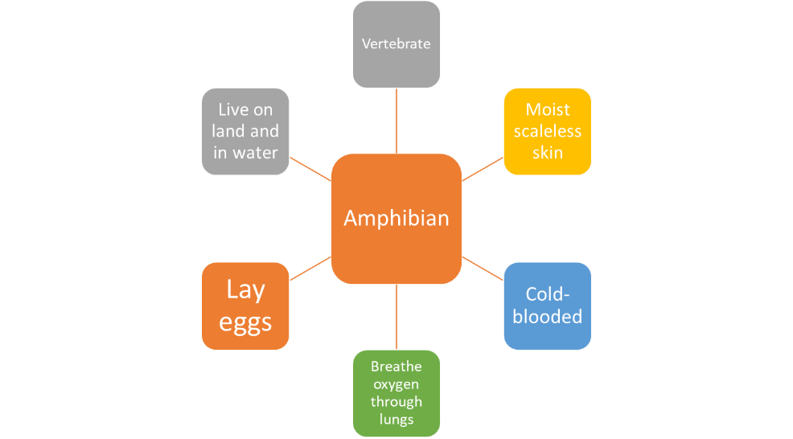
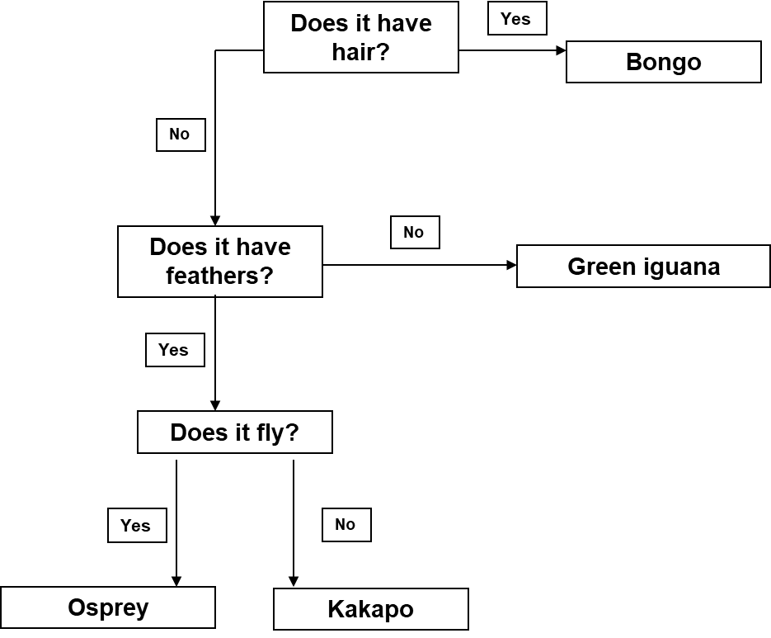
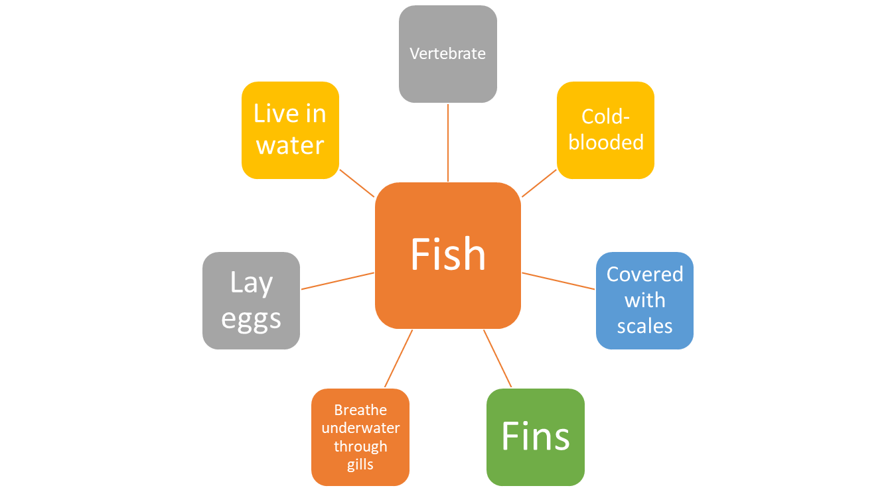
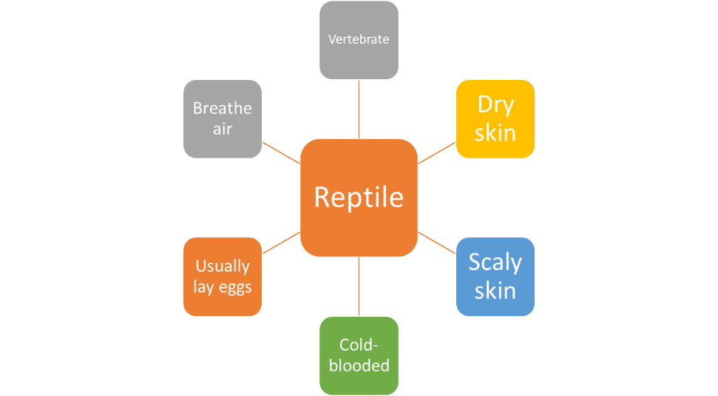
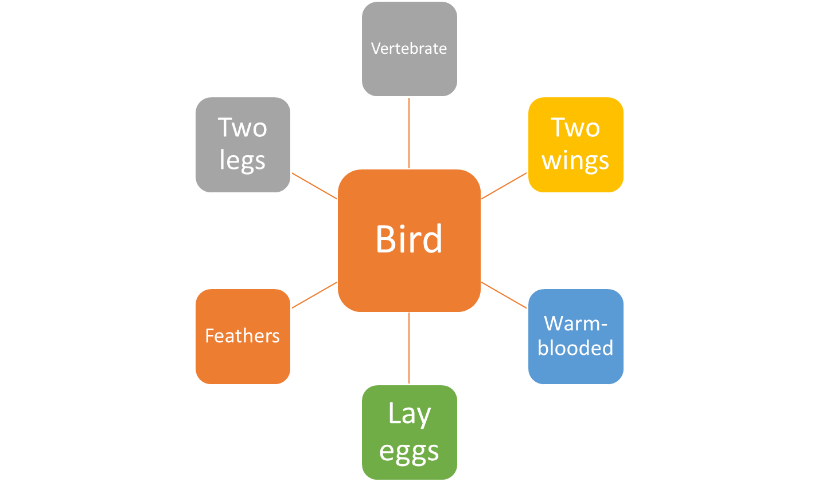
Always start with the first question.
The answer to each question should always be ‘yes’ or ‘no’.
Characteristics of vertebrate groups

