** Knowledge Organiser – Electricity (Science Year 3 and 4)**

|  |  |
| --- | --- |
| **Key Vocabulary** | **Definition** |
| Electricity | Form of energy that is carried through wires and used to operate lights, etc. |
| Plug | Device for making an electrical connection between an appliance and the mains. |
| Electrical circuit | Path in which electrons from a voltage or current flow. |
| Circuit symbol | Diagram of an electrical component. |
| Component | Part of a larger whole. |
| Cell | Device used to generate electricity. |
| Battery | Device that produces electricity, in parallel or series. |
| Conductor | Material that conducts or transmits energy. |

Energy can be transferred from one place to another in many different forms. Appliances can change electricity to light, heat, sound or movement energy.



Larger crystals that interlock.

Marble

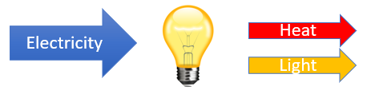

To construct a simple circuit, we need…



This continues in waves until the vibrations run out of energy. If the vibrations reach your ears, you will hear the sound.

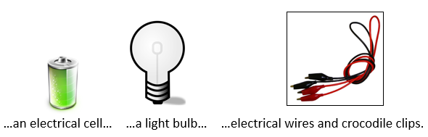

Some materials do not allow electricity to pass through them. These materials are known as electrical insulators.

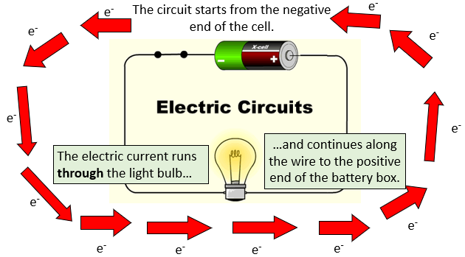

When a switch is open (off), there is a gap in the circuit. Electricity cannot travel around the circuit.

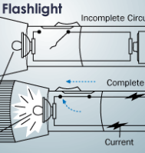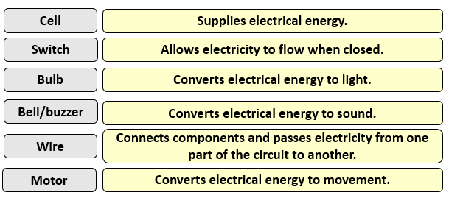

Many metals, such as copper, iron and steel, are good electrical conductors. That is why the parts of electrical objects that need to let electricity pass through are always made of metal.

When a switch is closed (on), it makes the circuit complete. Electricity can travel around the circuit.